Game Theory for Rebels
A Guide for the Oppressed

Part V



Ropes Pierre

Game Theory for Rebels
A Guide for the Oppressed

Part V

By Ropes Pierre

Published by:
The Swarm of Strategic Rebels
who Volunteer to share this document.
Copyright Notice (CC BY 4.0)

This work is released into the public domain under the Creative Commons Attribution Licence (CC BY 4.0). You are free to copy, distribute, and adapt this work, on condition that any derivative works or reproductions must properly name and credit the original source/author.

Since the author is anonymous, appropriate credit specifies where the author posts his philosophical work, more specifically https://thepragmaticrealist.substack.com/, and can be in several forms such as:

- "The Pragmatic Realist (Substack)", with or without hyperlink.
- "thepragmaticrealist.substack.com", with or without hyperlink.
- "Ropes Pierre", with hyperlink to Substack or the address displayed.
- "Ropes Pierre via The Pragmatic Realist (Substack)", with or without hyperlink.

Dedication

This project is meant to give hope to the hopeless. Oppression does not lead to a stable society, and while "might makes right" has been at the core of the world view of leaders for centuries, we prove herein that it does not lead to prosperity.

The manner in which this manuscript is intended to be shared is inspired by the printed pamphlets of Robespierre, a prominent figure in the French Revolution who tragically went mad trying to enact what I can only assume was a Masonic vision.

Robespierre initially gained popularity by insisting that the peasants must have access to justice if crimes are committed by the elites, and therefore I dedicate this work to him.

While we can learn from history, it is also possible to use Game Theory to avoid learning through trial by error. You are about to discover that Game Theory does present a way to structure society that ensures prosperity, but it requires us to change the way we look at leaders and power dynamics.

You do not need to burn down the system in order to fix it. You will soon see for yourself that there is a simple patch: Tit-for-Tat cost imposition. This results in an antagonistic balance where leaders are less tempted to Defect to Subverter interests, maximising the prosperity of the nation, or otherwise drastically escalating the odds of a tyranny falling.

However, Robespierre was right that the house needs to be cleaned. Allowing the old guard to train the new guard will certainly guarantee that the corruption remains intact. I therefore declare myself Ropes Pierre, because I am not calling for Guillotines!

Game Theory for Rebels 5:
The Ruler vs the Ruled
Monte Carlo Simulation

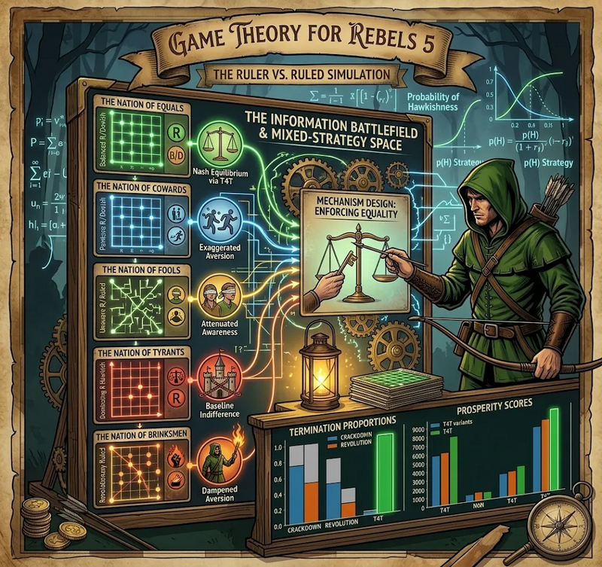
We previously established that the state is not a benevolent entity centred around public service, but a marketplace of competing Utilities – full of individuals trying to advance their careers or the wealth of their oligarchy.
From traditional Game Theory, we have discussed the Deterrence Game, the Game of Chicken, the Stag Hunt, the Volunteer’s Dilemma, the Hawk-Dove Game and the Prisoner’s Dilemma.
We also introduced the Ruler’s Dilemma in the previous section to explain why a Ruler population sometimes Defects and sometimes not, depending on whether they are selfish or communal when calculating value.
These scenarios were treated as single-round games, almost like a before and after analysis; the real world is more complicated than that. Society plays out like an Infinite-Horizon Mixed-Strategy Game.
Rather than describing the Strategies as Cooperate or Defect, we are going to describe them in terms of the Probability of Hawkishness, or simply Hawkishness.
Hawkishness represents the Mixed Strategy probability that a Player will Defect in the next turn.
The Ruler vs. Ruled Monte Carlo Simulation was created to map out the possibility space of various civilisational behaviours, with the particular aim of confirming that Tit-for-Tat is the superior Strategy in all cases, and confirming that the most prosperous approach to societies in general is to live in Antagonistic Balance, not passive compliance.
There is an interesting feature of a Monte Carlo simulation like this, tied to the fact that Strategies are defined in terms of the Probability of Hawkishness: the Monte Carlo simulation explores both rational and irrational strategies, since randomisation could produce either. That means that Tit-for-Tat even defeats an irrational opponent, on average.
The only way to distinguish a rational Strategy from an irrational one is the presence of a logical story to explain each step, and so they are indistinguishable from each other if you aren’t looking at the reasons for the decisions.
Game Theory for Rebels 5 will explain the results of the simulation, demonstrating that Antagonistic balance is a mathematically verified means of Shared Value Maximisation.
It will also demonstrate that Tit-for-Tat cost imposition is the best way to enforce Antagonistic Balance, regardless of the opponent’s Strategy. Doing so results in a situation that resembles a Nation of Equals if neither player is particularly Aggressive, otherwise Tit-for-Tat favours the less Aggressive side.
We will begin by explaining the mechanics of the simulation. Thereafter, we will discuss the lethality of blind controls, the psychology of 5 National Archetypes of Aversion to societal value degradation, and the impact of innate Aggression from the Ruler or Ruled population.
We will end by reiterating the strategic perspective proposed in Game Theory for Rebels, and validated via simulation, for the Strategic Rebel seeking to dismantle an oppressive regime without burning down the society that they aim to liberate.
Ultimately, what we are proposing is to maintain a Nation of Equals situation
by using Tit-for-Tat cost imposition strategies to enforce mutual Cooperation.
We also need to give the Ruled a threat advantage by rewriting the constitution of the nation using Mechanism Design to ensure mutual Cooperation and protect Tit-for-Tat mechanisms.

Simulating Conflict Between
the Ruler and the Ruled

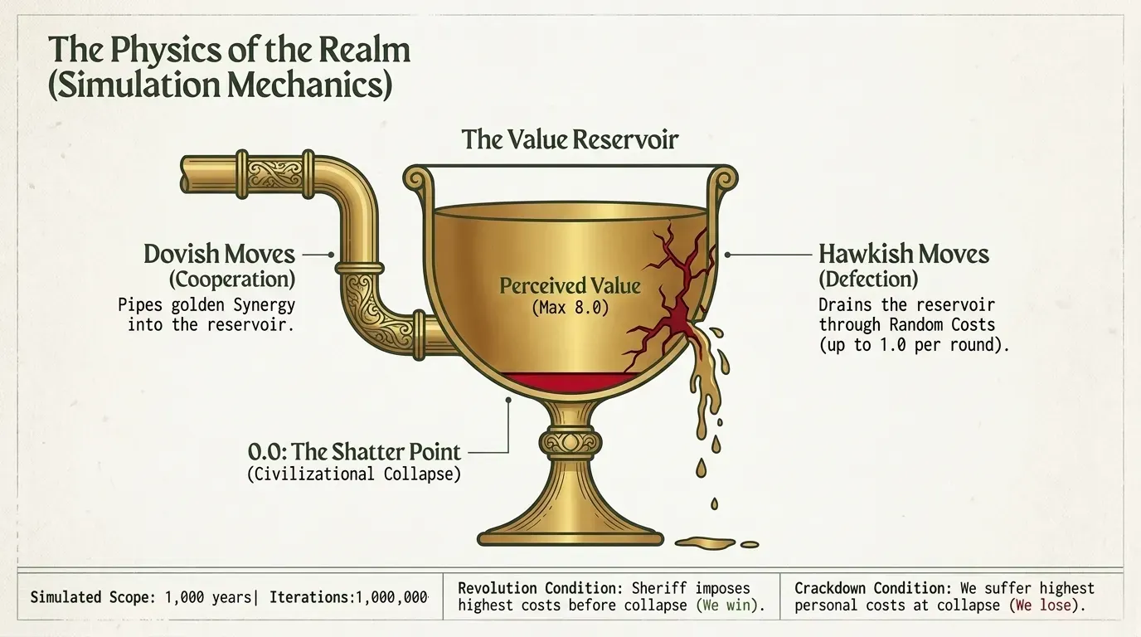
The Ruler and the Ruled share a society, and are therefore competing for a shared value that we will call the Perceived Value of society.
The Players can either create conflict by being Hawkish (prone to Defection), or they can create value by being Dovish (prone to Cooperation). If one Player is Hawkish and the other is Dovish, the impact on Perceived Value is determined by the relative size of the Defection and Cooperation.
Each simulation covers 1000 rounds of the game, which you can think of as 1000 years of civilisation. It keeps track of the Prosperity Score, the Personal Costs of each Player, and the termination conditions if a game terminating event occurs.
The Perceived Value of Society is capped at 8.0 to ensure that the majority of National Archetypes experience state failure at least once during the simulation, so that termination conditions can be compared.
Costs are calculated randomly to account for the fact that some moves have a large impact and some have a small impact. The maximum net contribution to Cost per round is between -1.0 and 1.0, for mutual Cooperation and Defection respectively.
Each simulation was repeated one million times, although aggregate data can include more data points than that.

Perceived Value and Game Terminating Events
Utility-maximising individuals form civilisations in order to maximise personal Utility through the Utility of Synergy.
Perceived Value is the Utility that is available within society, including cash flows, personal happiness, the ability to actualise personal freedoms, level of inspiration, etc.
If a Player makes a Hawkish move, they impose random Costs on both themselves and the opponent. A Dovish move imposes random negative Costs (benefits) on both the Player and his opponent.
In each round: both Players make a move, Personal Costs are calculated for each Player, and Net Cost to Perceived Value is calculated by adding individual scores together.
The game ends in civilisational collapse if the Residual Perceived Value, after subtracting Net Costs, reaches zero. At this point, there is no Utility in continuing the system. The portion of Net Cost experienced by each individual player is called their Personal Cost.
The side with the highest Personal Costs have more to gain from overthrowing the system, while the side with the least Personal Costs has more to gain from maintaining the system.
Therefore, if the Ruler population has imposed the highest Personal Costs on the Ruled, it ends in a Rebellion. If the Ruler experiences the highest Personal Costs when society collapses, it ends in Crackdown.

The 5 National Archetypes of Aversion to Societal Decline
We can define five National Archetypes to model the different ways that the Ruler and Ruled populations can respond to seeing societal decline: deteriorating Residual Perceived Value of society.
At the beginning of a simulation, each player is assigned a Strategy in terms of Probability of Hawkishness. As the simulation pregresses, an Aversion Penalty is applied so that the Strategies changes in response to societal decline.
The Ruler population can never have a Hawkishness below 10%, even with penalties applied. This accounts for the fact that laws need to be established and enforced in order to prevent or manage foreseeable conflicts in order to maximise the Utility of Synergy associated with the society.
Aversion Penalties, as well as the underlying Aversion Scores, are always between 0 and 1. These will be explained in more detail later on.

The Nation of Cowards
Both players panic with the same intensity if they see signs of societal decline. Both sides are extremely likely to Cooperate just to avoid losing Perceived Value.
The Aversion Penalty is the square of the Aversion Score, and is the same for both players.

The Nation of Equals
Both sides are rational, and respond with the same intensity when they see society decline.
The Aversion Penal grows linearly, being just the unaltered Aversion Score, and is the same for both Players.

The Nation of Fools
Both Players either ignore the deterioration of society or it is partially hidden from both Players.
The Aversion Penalty is the square root of the Aversion Score, and is the same for both players.

The Nation of Tyrant Rulers
The Rulers are insulated from societal Decline, and respond with a sub-linear Aversion Penalty.
The Ruled are a normal populace with a linear Aversion Penalty.
The Rulers have a Baseline Indifference of 2/3, and are willing to tolerate more societal deterioration just to enforce their will.

The Nation of Brinksmen Ruled
The Rulers are ordinary people, responding with a linear Aversion Penalty.
The Ruled are ideologically driven, with a sub-linear Aversion Penalty.
The Ruled have a Baseline Indifference of 2/3, and are willing to tolerate more societal deterioration just to try to force their demands.

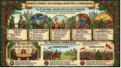

The 3 National Demeanours
The National Demeanours describe the baseline posture of a society before the dynamic choices of the Ruler and Ruled populations take effect. They represent symmetric and asymmetric power relationships, expressed in terms of willingness to play Hawk.
Each Demeanour simulation was repeated with the non-Aggressive or Neutral Players playing Tit-for-Tat. To mimic real world uncertainty, we use a probabilistic Tit-for-Tat algorithm and so retaliation is not always guaranteed and is not always justified.
In Probabilistic Tit-for-Tat, the Probability of Hawkishness randomly changes for the Tit-for-Tat player so that it is above 50% if the opponent makes a Hawk move and below 50% if the opponent makes a Dove move, but always staying above 10% for the Ruler population.
An Aggressive Player always has a Hawkishness above 50%, even with Aversion Penalties applied, and never plays Tit-for-Tat because their Hawkishness must always be above 50% prior to penalties.

Neutral Temperament (NN)
A balanced constitutional order where both Ruler and Ruled are assigned a Strategy at the start by randomly generating the Probability of Hawkishness.
Both play Tit-for-Tat in the Tit-for-Tat variant.

Aggressive Ruler
An autocratic baseline where the Ruler’s Hawkishness is always 50% or higher, relying on police coercion, surveillance, and structural suppression as standard tools of governance.
Only the Ruled play Tit-for-Tat in the Tit-for-Tat variant.

Aggressive Ruled
An insurgent baseline where the Hawkishness of the Ruled is always 50% or higher, representing a heavily radicalised public, militant trade union movement, or revolutionary vanguard.
Only the Ruler plays Tit-for-Tat in the Tit-for-Tat variant.

The Danger of Ignorance and Strategic Blindness

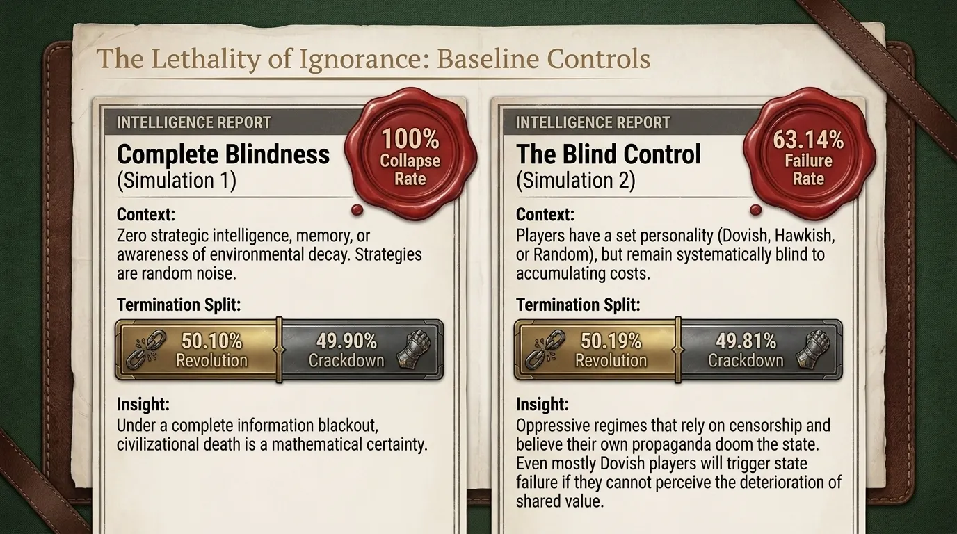
To measure the impact of psychological profiles, strategic reactivity, and decay awareness, we must first establish what political friction looks like without them.
The simulation pipeline constructs two foundational control environments: Simulation 1 (Stochastic Noise) and Simulations 2 & 9 (the Blind Controls).
These represent a system where both Players have Strategic Blindness: they are incapable or unwilling to change their Strategy in response to observables.
If the Players have Strategic Blindness to societal decline, the majority of states will fail.
In Simulation 1, states failed 100% of the time, with 50.10% ending in Revolution and 49.90% ending in Crackdown.
Across the entire set of possible behavioural combinations considered in Simulation 2, the Total Failure Rate was 63.14%, split nearly evenly at 50.19% Revolution rate and a 49.81% Crackdown rate.
Even if both players were mostly Dovish, states still failed due to Systemic Blindness.

Simulation 1: Complete Blindness
Simulation 1 randomises both the Strategy and the Costs at every step to cover the complete possibility space.
Both the Ruler and the Ruled operate with zero strategic intelligence, zero memory, zero awareness of environmental decay and do not even know if they are Hawkish or Dovish.
Both Players are assigned a random Probability of Hawkishness at every step of the game. This simulates a situation where the players are either entirely irrational or completely blind to the nature and consequences of their actions.
Under a complete information blackout, society collapses 100% of the time in the simulations. Stable civilisations are possible, so we interpret this as a number that is extremely close to, but smaller than 100%.
Without reacting to the decline of society, society collapses just under 100% of the time, with a split nearly 50/50 between Revolution or Crackdown.

Simulation 2 and 9: The Blind Control Baseline and Tit-for-Tat Variant
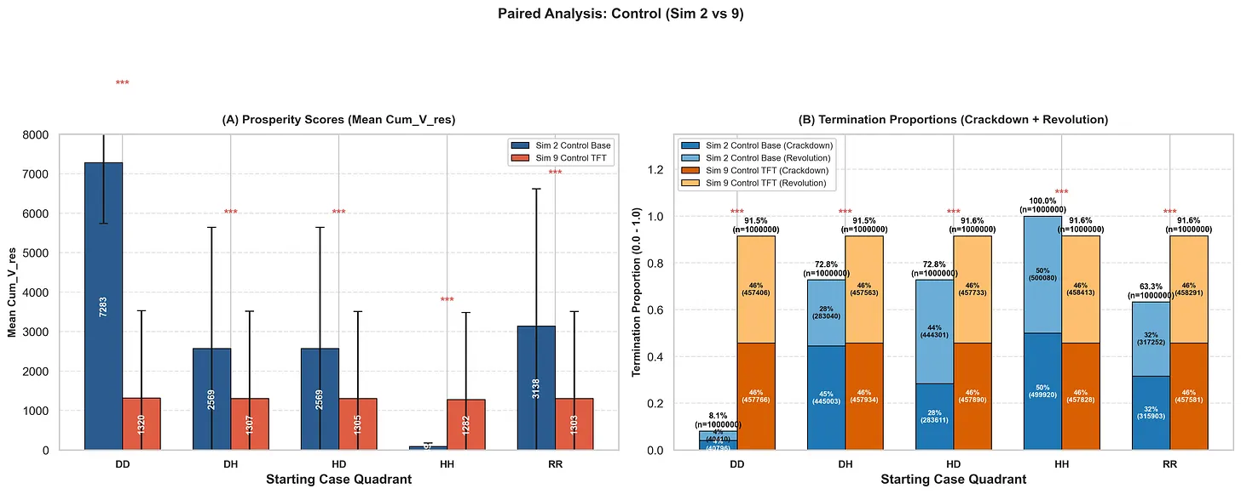
The second set of simulations assigns personality to the Ruler and the Ruled by dividing them into 5 categories based on Dovish (D), Hawkish (H) or random (R) Strategies: DD, DH, HD, HH, and RR.
A Dovish Player has a Hawkishness below 50% and a Hawkish Player is above 50%, while a Random Player can have any value from 10% to 100% for the Ruler and 0% to 100% for the Ruled.
If you combine the data for these 5 cases, the result resembles the RR data. This confirms that all scenarios are accounted for proportionately and that we can use the combined set of simulations as our control data.
If both Ruler and Ruled populations play Hawk, the state collapsed 100% of the time with a nearly 1:1 ratio for Revolution and Crackdown. This outcome is nearly identical to complete blindness, except that Tit-for-Tat is able to rescue some of these societies.
If both Players are Dovish, states can still collapse because neither has a Hawkishness of zero.
It is interesting to note that the Hawk tends to win for DH and HD cases and that Tit-for-Tat leads to escalation spirals, as intuition would suggest. On the other hand, we do not see these trend when Players are aware of societal decline...

Sensitivity to Societal Decay

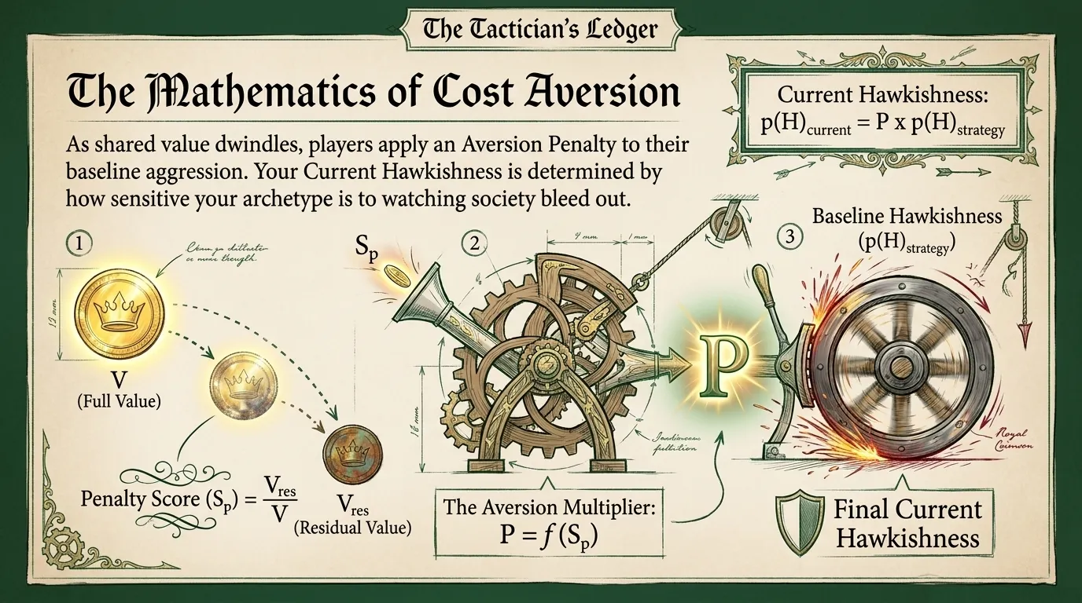
Broadly speaking, there are five ways in which Players can respond to a decline in shared value, corresponding to the National Archetypes discussed earlier.
There are three symmetrical responses corresponding to high, mild and low Aversion to societal decline and the Nations of Cowards, Equals, and Fools, respectively.
Then there are two asymmetric responses where either the Ruler or the Ruled care less about the decline of society than the other, corresponding to the Nation of Brinksmen and the Nation of Tyrants.
Aversion Penalties are implemented as follows:

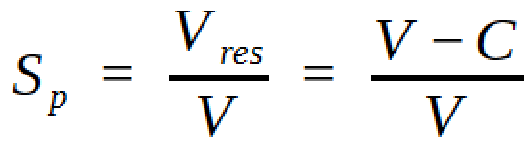

An Aversion Penalty is applied as a multiplier to each Player’s Strategy, which reduces the Probability of Hawkishness, p(H), proportionally to the decline in Perceived Value.
The Aversion Penalty Multiplier, P, is a function of the Penalty Score, SP, which is Residual Perceived Value divided by the full Perceived Value.
The Residual Perceived Value, Vres, is the difference between full Perceived Value, V, and Net Costs, C.
As the Residual Perceived Value decreases, the Aversion Penalty of each player increases proportionally, but we will discuss the specifics of the Aversion Penalty Multiplier Functions, P = f(SP), for each archetype.
The Baseline Hawkishness, p(H)Strategy, is assigned to a player at the start of a simulation, while the Current Hawkishness, p(H)current, takes Aversion Penalties into account.
The Prosperity Score is merely the sum of Residual Perceived Value at the end of every round, and represents the proportion of the nation’s prosperity that it manages to maintain despite societal conflicts.
The Ruler can never have a Hawkishness below 10%, even after penalties are applied.

The Nation of Cowards

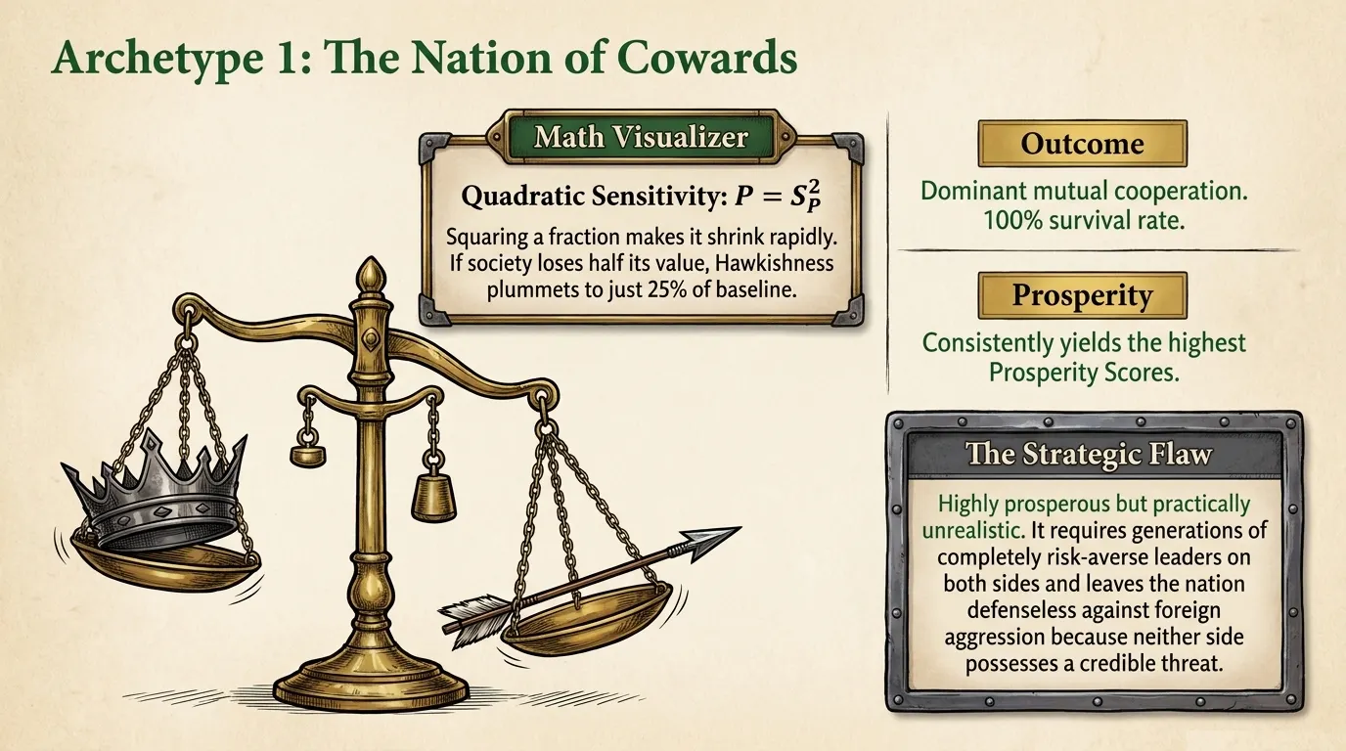
When both Players have an exaggerated Aversion to seeing the decline of society, we refer to that archetype as a Nation of Cowards.
Such a nation is driven to Cooperation because both sides are afraid of losing what they have, and would rather abandon a fight than risk escalating Costs.
The Aversion Penalty Multiplier Function for a Nation of Cowards is the Penalty Score squared:
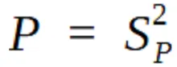
Since Aversion Penalties are the square of Aversion Scores, the Hawkishness of both Players decreases significantly as the Residual Perceived Value approaches zero. Remember that Penalty Score, SP, values are between 0 and 1.
When a Nation of Cowards loses half its value, Players reduce their Hawkishness to 25% its baseline value.
While this ends up being the best performing archetype, that only holds true if both sides have a high Aversion to societal decline. However, every generation of leaders is different, and so in the real world this approach is not practical.
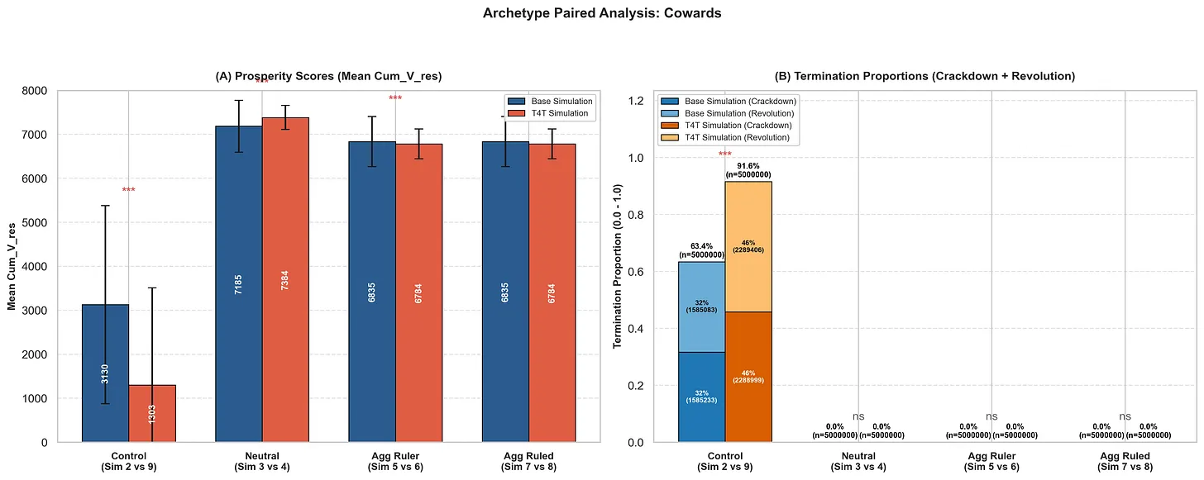
We expect just under 100% of cases to survive to the end of the simulation, even though we are most likely to observe a 100% failure rate.
Because of the strong Aversion to societal decay, the dominant interaction between the Ruler and Ruled populations was mutual Cooperation.
The Nation of Cowards consistently had the highest Prosperity Scores due to their inclination towards mutual Cooperation. Prosperity Scores were enhanced further if both sides played Tit-for-Tat.
Because the Hawkishness of the Ruler can never go below 10%, regardless of penalties, only the Ruler is capable of creating game-terminating events in a Nation of Cowards – and only by stumbling into them by chance.
If neither Player is particularly willing to play Hawk, then neither the Players nor the nation that they represent can have a credible threat of retaliation to foreign aggression. The Ruler vs Ruled simulation does not take foreign actors into account, and so it is necessary to emphasise this point.

The Nation of Equals

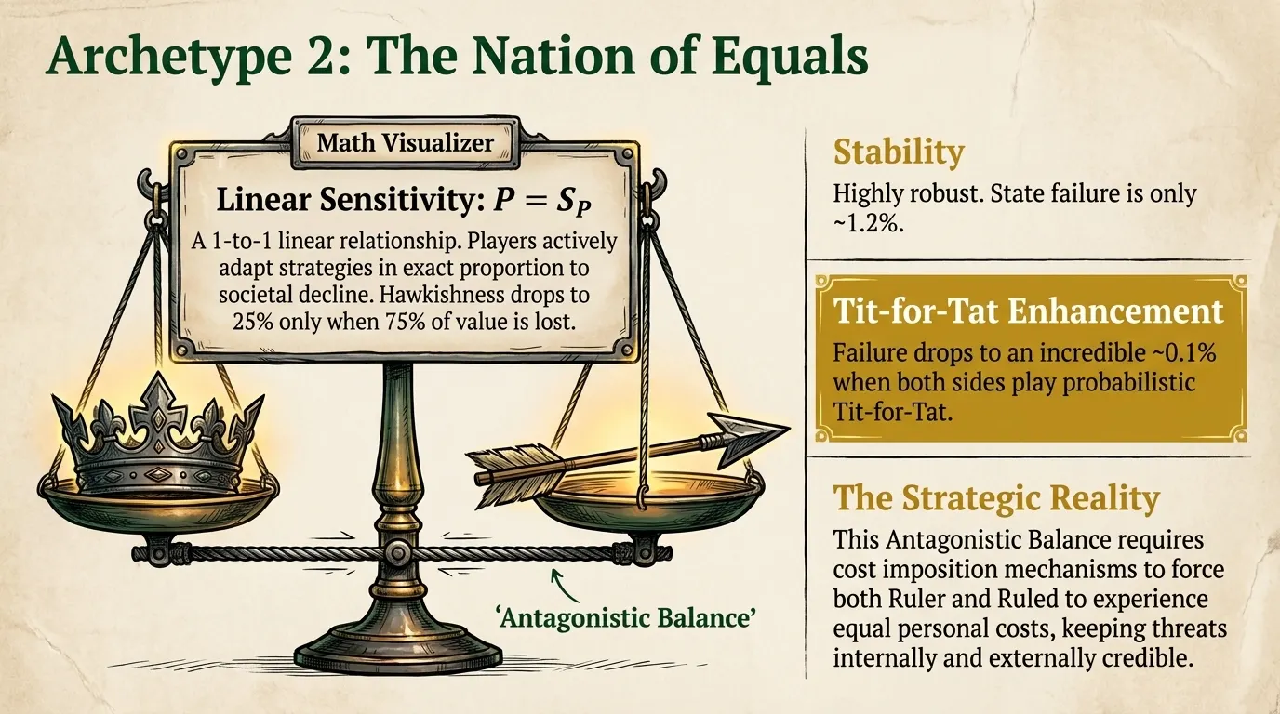
When both Players have an Aversion to seeing the decline of society that is equal to the degree of societal decay, we refer to the Aversion archetype as a Nation of Equals.
This national archetype is driven to Cooperation by a measured, rational response to seeing societal decline, but has no compulsion to Cooperate is there is no decline.
The Aversion Penalty Multiplier Function for a Nation of Equals is simply the Penalty Score:
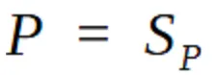
Since Aversion Penalties have a 1-to-1 linear relationship with the Penalty Score, SP, Players are changing their Strategies actively and proportionally as society declines.
By the time a Nation of Equals has lost 75% of its value, Players have reduce their Probability of Hawkishness to 25% of its baseline value.
This archetype performs nearly as well as the Nation of Cowards, but results in a more stable national configuration.
If both sides are responding linearly to societal decay, then a Nash Equilibrium could exist where each side keeps the other side acting as an Equal by imposing proportional Personal Costs on the other.
The rest of our data seems to support the hypothesis that Tit-for-Tat enforces such a Nash Equilibrium.
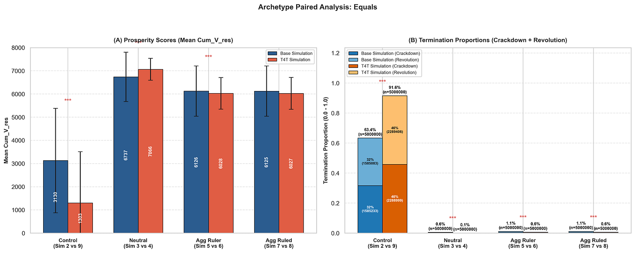

The Nation of Equals was remarkably robust, with only ~0.6% of the simulations ending in state failure. This drops down to ~0.1% if both sides play Tit-for-Tat. If an Aggressive Player was present, Termination proportions rose to ~1.1%, and ~0.6% for Tit-for-Tat.
The Prosperity Scores were similar to but slightly lower than the Nation of Cowards. Prosperity Scores were enhanced further if both sides played Tit-for-Tat unless an Aggressive Player was present, in which case it fell by ~1.6% in exchange for a more stable society.
Game terminating events are rare because both Players have a tendency towards more mutual Cooperation the more it becomes apparent that conflict is lowering the Perceived Value of society. However, when the society is not in dire straits, either side is more likely to play Hawk.
Realistically, the only way to have a real Nation of Equals is if there are cost imposition mechanisms that ensure that the Ruler and Ruled experience similar personal costs. This means that threats have to be credible internally, and so a foreign aggressor is likely to take threats seriously too.

The Nation of Fools
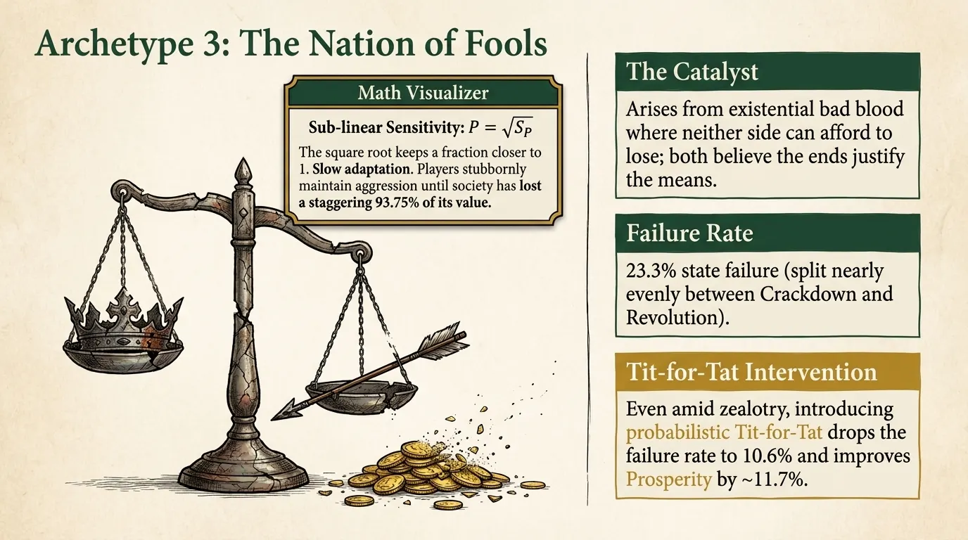

When both Players have an attenuated Aversion to seeing the decline of society, we refer to the Aversion archetype as a Nation of Fools.
Such a nation is not driven to Cooperation when seeing the decline of society, because either neither side cares or neither side can see the decline.
The Aversion Penalty Multiplier Function for a Nation of Fools is the square root of the Penalty Score:
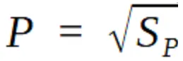

Aversion Penalties are the square root of the Penalty Score, so both Players are slow to adapt their Strategies in response to societal decline. Bear in mind that Penalty Scores, SP, are between 0 and 1.
In a Nation of Fools, Players only reduce their Probability of Hawkishness to 25% of its baseline value when the Perceived Value of society has already lost 93.75% of its original value.
A Nation of Fools arises when there is bad blood between the Ruler and the Ruled, such that a conflict between the two could be existential. Neither side can afford to lose, and so are willing to overlook the decay of society. Both sides believe that the ends justify the means.
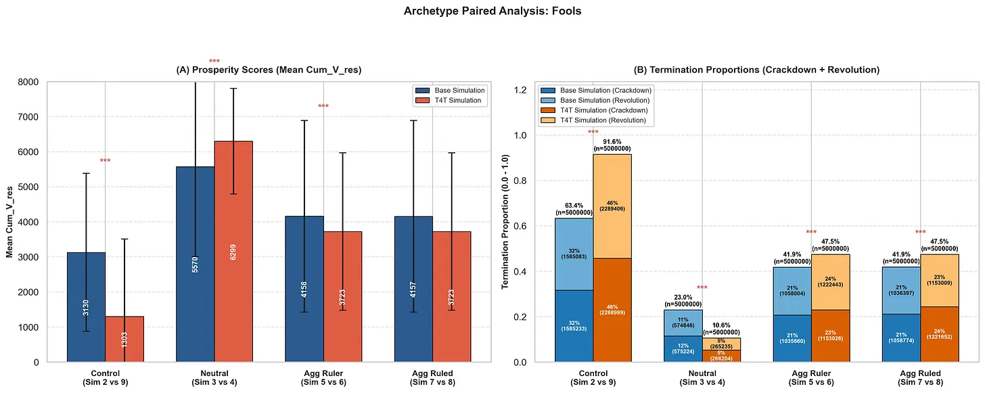
The Nation of Fools had a failure rate of ~23.0%, split nearly evenly between Revolution and Crackdown. This reduced to ~10.6% if both sides played Tit-for-Tat, illustrating how potent the nation-stabilising effect of probabilistic Tit-for-Tat can be.
The Prosperity Score of a nation of Fools is significantly lower than the Cowards (-22.5%) or Equals (-17.3%), but improves by ~13.1% if both sides play Tit-for-Tat.
Game terminating events are an almost even split between Revolution and Crackdown. If an Aggressive Player is present, Tit-for-Tat increases the odds of the other Player winning from ~50% to ~51%, while increasing the chance of societal collapse by ~5.6%.
A Nation of Fools represents a nation whose Ruler and Ruled populations are both willing to overlook their own harm in pursuit of an agenda, and so a foreign nation is likely to see their threats has highly credible.
The Nations of Fools archetype has a worse Prosperity Score than the asymmetric archetypes that follow, but is in a similar class to them. Nevertheless, it was the worst of the National Archetypes by all metrics.

The Nation of Tyrants

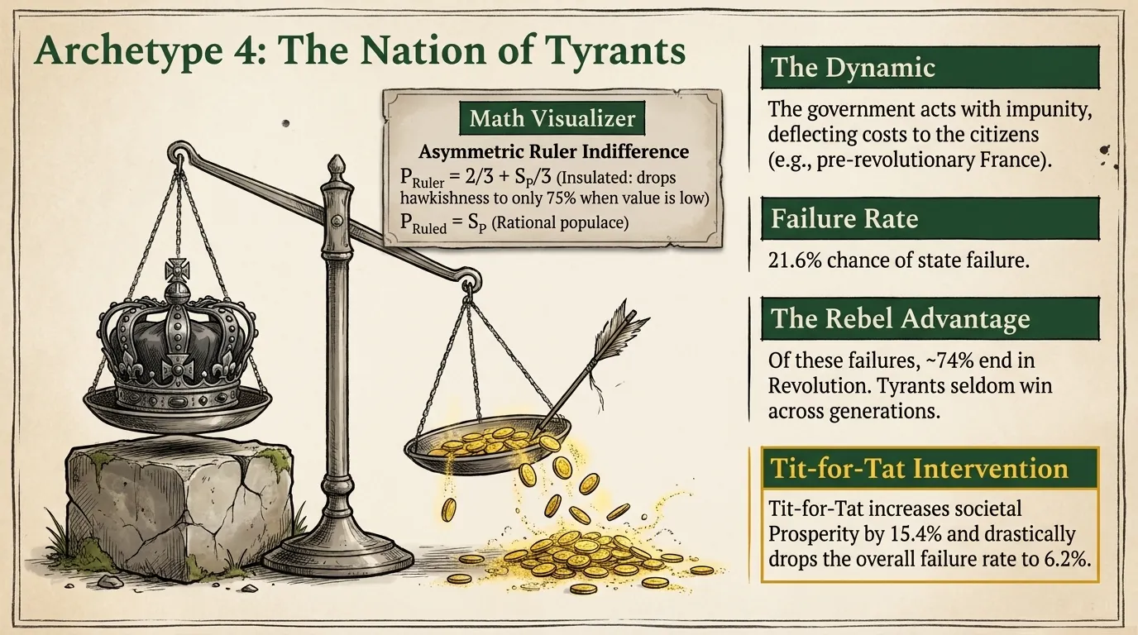
When the Rulers have a dampened Aversion to societal decay compared to the Ruled, we refer to the Aversion archetype as a Nation of Tyrannical Rulers, or a Nation of Tyrants.
The Aversion Penalty Multiplier Functions for a Nation of Tyrants are:
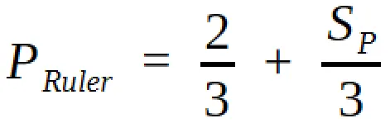
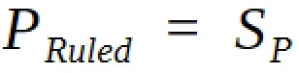
Both the Ruler and the Ruled populations have a linear Aversion Penalty, but the Ruler population’s Aversion Penalty is dampened to a maximum of 1/3 of the Penalty Score, with a Baseline Indifference of 2/3. Penalty Scores, SP, are between 0 and 1.
The Ruled is more likely to Cooperate as society declines, trying to preserve value, while the Ruler is more likely to Defect - guaranteed by the asymmetric Aversion Penalties.
This mirrors the real world, where people tend to keep their heads down and avoid confrontations prior to revolutions, but become revolutionary when that approach deepens the crisis.
In a Nation of Tyrant, by the time the Aversion Penalty of the Ruled reduces their Probability of Hawkishness to 25% the baseline value, the Ruler will only reduce his Hawkishness to 75% of the baseline value.
This archetype represents any authoritarian regime that would rather turn to force or police violence than to listen to, or represent, the concerns of the citizens. It is the government that acts with impunity, not heeding warning signs.

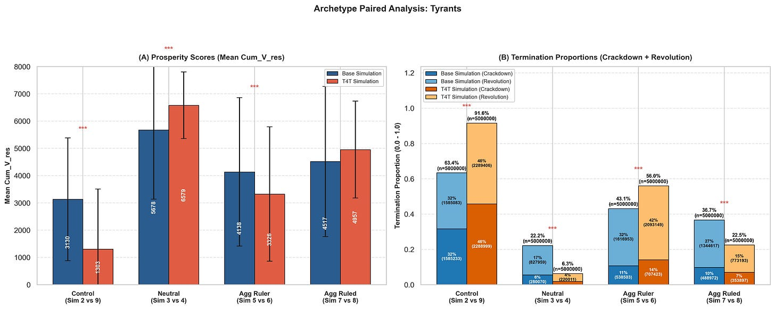
The Nation of Tyrants had a ~22.2% chance of state failure. The failure rate reduces to ~6.3 % if both sides play Tit-for-Tat. About ~76.6% of the time the simulations ended in Revolution, going down by ~13.1% (to ~63.5%) if both sides play Tit-for-Tat.
If the Ruler is also Aggressive (Defects more than 50% of the time), Termination Proportions rise significantly to 43.1% and 56.0% if the Ruled played Tit-for-Tat, with the Ruled winning ~74.4% and ~75.0% of the time, respectively.
The average Prosperity Score is ~15.7% less than the Nation of Equals, and increases by ~15.9% if both players play Tit-for-Tat.
That is just ~2.3% less than Nation of Equals, suggesting that Tit-for-Tat imposed a Nation of Equals dynamic on the Tyrant, while still keeping the chance of Revolution high.
A Nation of Tyrants is likely to be seen as aggressive by foes, and therefore a foreign state is likely to take threats seriously, knowing that the Ruler has a Baseline Indifference to damage.
We also observe in the real world that tyrannies tend to be short-lived compared to other forms of government, with the Tyrants seldom winning over the course of generations.

The Nation of Brinksmen

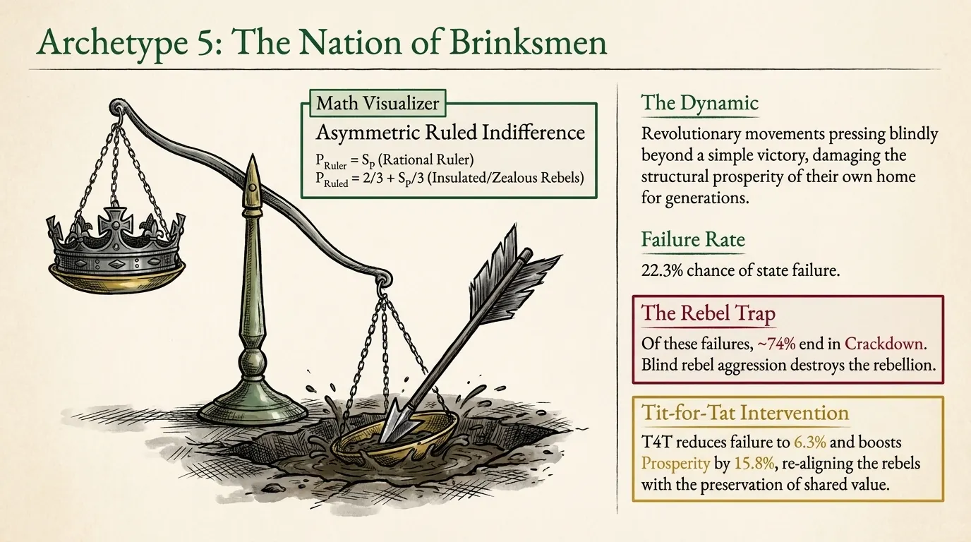
When the Ruled has a dampened Aversion to societal decay compared to the Rulers, we refer to the Aversion archetype as a Nation of Brinksmen Ruled, or a Nation of Brinksmen.
The Aversion Penalty Multiplier Functions for a Nation of Brinksmen are:
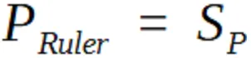
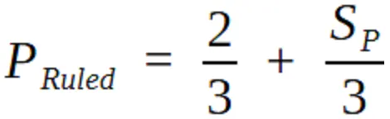
Both the Ruler and the Ruled population has a linear Aversion Penalty, but the Ruled population’s Aversion Penalty is dampened to a maximum of 1/3 of the Penalty Score, with a Baseline Indifference Level of 2/3. Penalty Scores, SP, are between 0 and 1.
The Ruler is more likely to Cooperate as society declines, but the Ruled is more likely to Defect, guaranteed by the asymmetric Aversion Penalties.
In a Nation of Brinksmen, by the time the Aversion Penalty of the Ruler reduces their Probability of Hawkishness to 25% of the baseline value, the Ruled will only reduce his Hawkishness to 75% of the baseline value.
This case represents may revolutionary movements of the past, who pressed beyond a simple victory and ended up damaging their society for generations as a result, rather than building genuine prosperity based off of compromise for the sake of mutual benefit.
It also represents the movements that were crushed because they were too ideological or aggressive at the start.
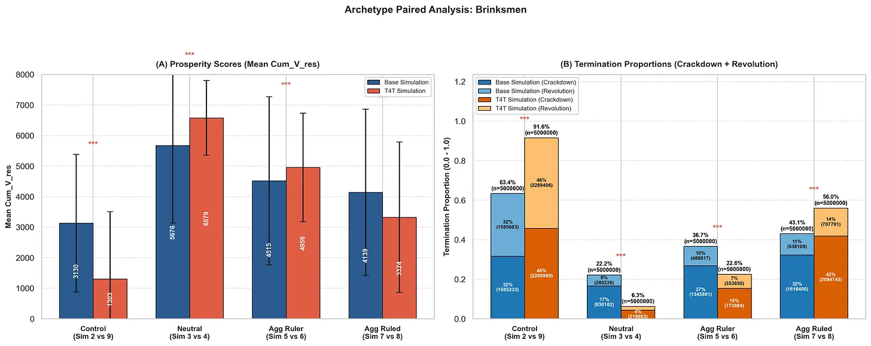
The Nation of Brinksmen had a ~22.2% chance of state failure, which reduces to ~6.3 % if both sides play Tit-for-Tat. About ~76.6% of the game terminating events were Crackdown, only going down by ~6.7% (to ~69.9%) if the Ruled plays Tit-for-Tat.
The average Prosperity Score is ~15.7% less than the Nation of Equals, and increases by ~15.9% if both players play Tit-for-Tat (to just ~2.3% less than Nation of Equals).
The Nation Of Brinksmen archetype demonstrates that there is a danger in a Strategic Rebel movement being too aggressive, suggesting that if you are not aware of the damage you are doing, you are likely to fail.
It is not clear how a foreign nation would interpret a threat from a Nation of Brinksmen, since it depends on whether the Ruler and Ruled population actually agree, or if the Brinksmen Ruled are unilaterally pushing for escalation or de-escalation.

Insights from the National Archetypes

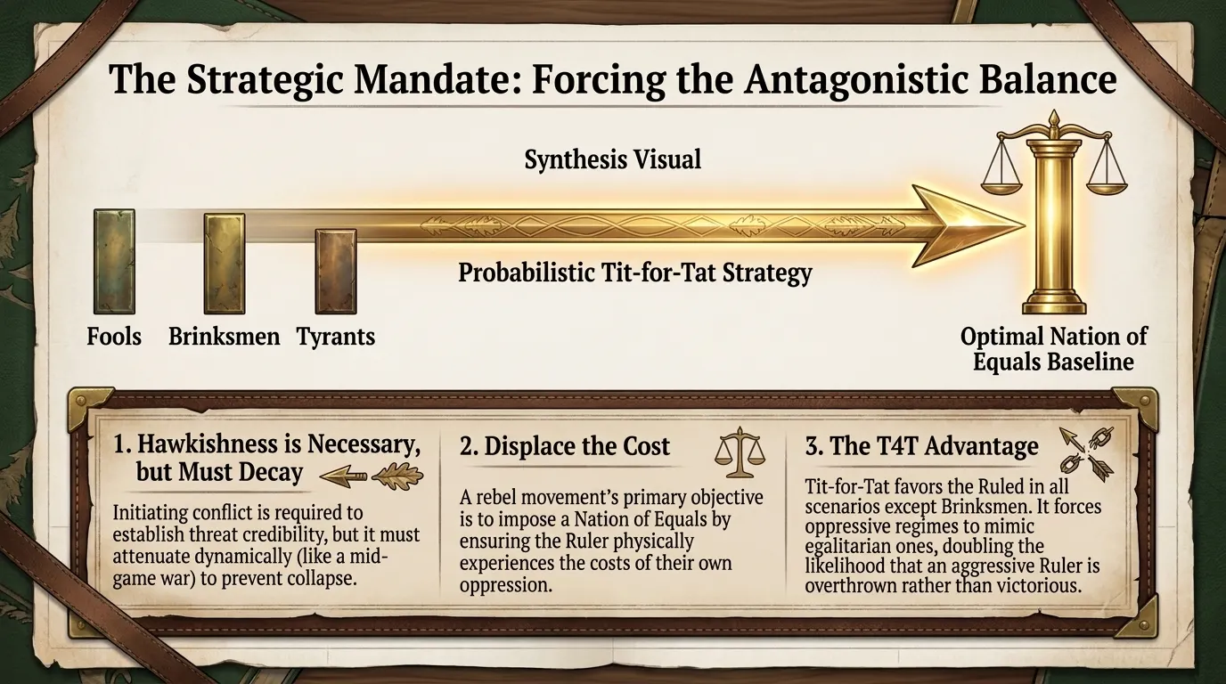
The core principle that emerges from the National Archetypes data is not that Hawkish behaviour should be avoided for a society to prosper. Some level of Hawkish behaviour from both the Ruler and the Ruled is actually necessary for prosperity!
Both the Ruler and the Ruled needs to be sensitive to the damage that they cause, in such a way that their Strategy has more freedom to cause damage in early stages and then adjusts to less Hawkish behaviour as the conflict progresses.
This is actually a similar pattern that we see in the start and mid-game of wars. They tend to start with a large-scale assault as both sides try to weaken the other, and then the rate of fire decreases as both sides settle in for a long battle.
However, given how an Ephemeral Solution Franchise is structured to decay in Utility over time due to high Risk, this also corresponds to an activism technique of starting with high-Risk publicity stunts and then attenuating to lower Risk activities to accommodate a growing movement.
A Strategic Rebel movement should seek to impose a Nation of Equals dynamic by ensuring that the Ruler population experiences Personal Costs for their actions, rather than displacing all the Costs of Defection onto the Ruled.
The Nation of Fools, Nation of Brinksmen and Nation of Tyrants were the three worst performers in terms of Prosperity Score, but when Tit-for-Tat was introduced their Prosperity Scores climbed to just under 3% less than the Nation of Equals.
This suggests that the probabilistic Tit-for-Tat algorithm, where retaliation is not guaranteed but the threat is still credible, makes these archetypes resemble a Nation of Equals, and is therefore likely to be a mechanism for enforcing a Nation of Equals archetype.
The data also suggests that once a Nation of Equals is created, its Prosperity Score can still increases further if Tit-for-Tat stays in place.

The Three National Temperaments

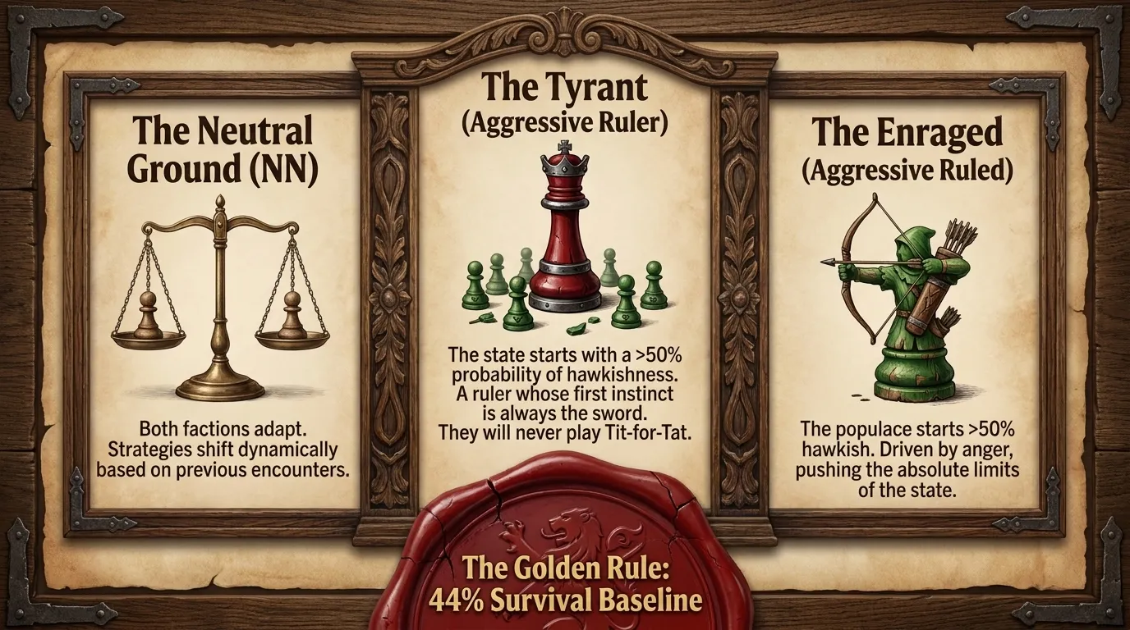

The National Archetypes represent the reactions of Players to observing a decline in societal value. The Three National Temperaments are designed as a stress test of the National Archetypes. They are: Neutral Temperament (NN), Aggressive Ruler (Agg Ruler) and Aggressive Ruled (Agg Ruled).
The idea was to take the basic simulations that we have discussed, and see what happens if you guarantee that the Ruler or the Ruled start the game with an Aggressive Temperament, represented by a Baseline Probability of Hawkishness above 50%.
Aggressive Players do not play Tit-for-Tat, they use the same Strategy in terms of Probability of Hawkishness for each round, prior to calculating Aversion Penalties. The Aversion Penalties are applied to each Player as usual.
Aggressive Temperaments seem to destabilise the state. The highest Termination Proportion observed being 56%, corresponding to a survival rate of 44% even if one Player has an Aggressive temperament.
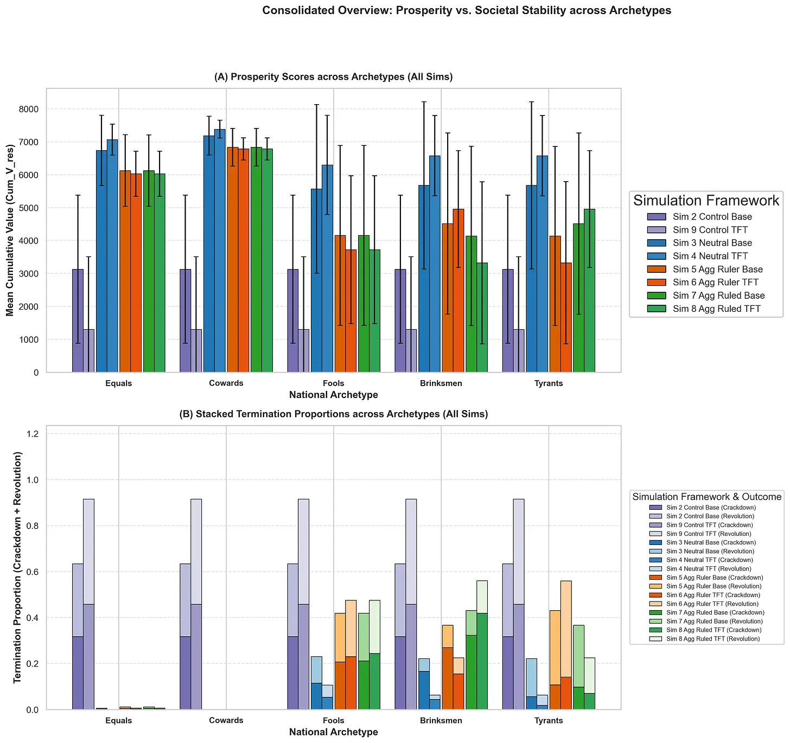

The Neutral (NN) Temperament
The Neural Temperament (NN) simulations are the standard simulation of the 5 National Archetypes and the Tit-for-Tat variant that we have already discussed. We will therefore be focusing on the lessons we can learn when a population is Aggressive instead.
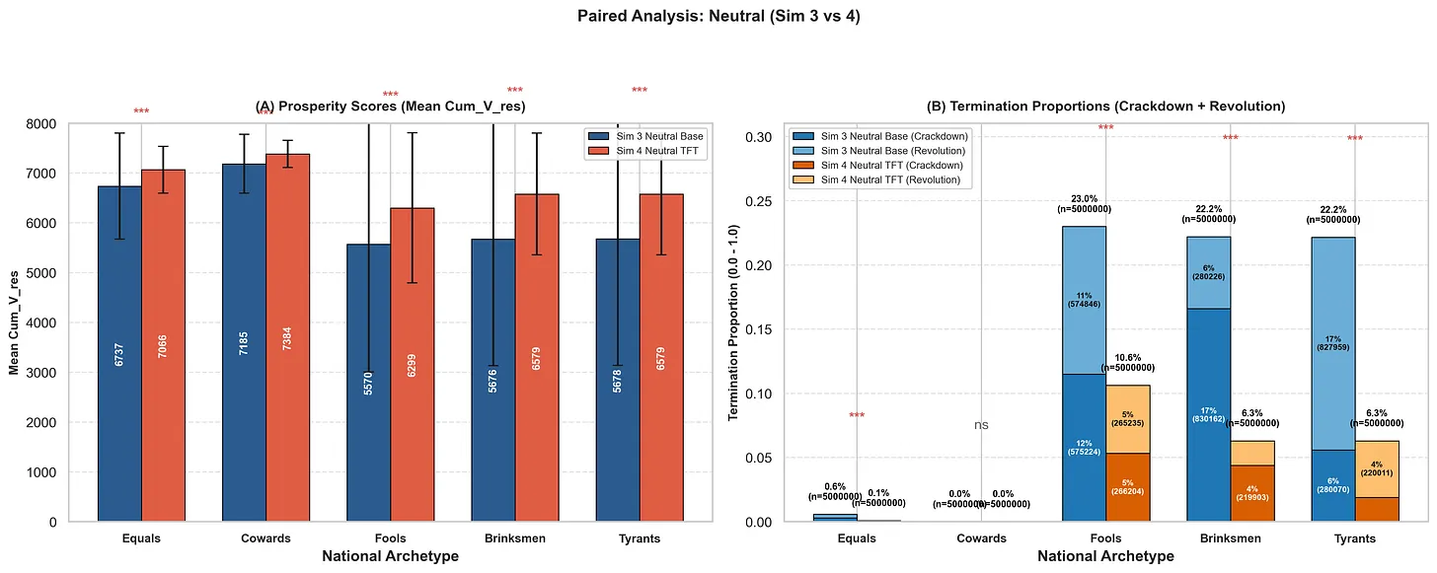
Both Players are assigned a random Strategy at the beginning of the game, but both players abandon that for Tit-for-Tat after the first round in the Tit-for-Tat variant.
This case represents the majority of possible nations, including the Aggressive variants, and so the other two cases are subsets of the Neutral-Neutral data.

The Aggressive Ruler (Simulations 5 & 6)

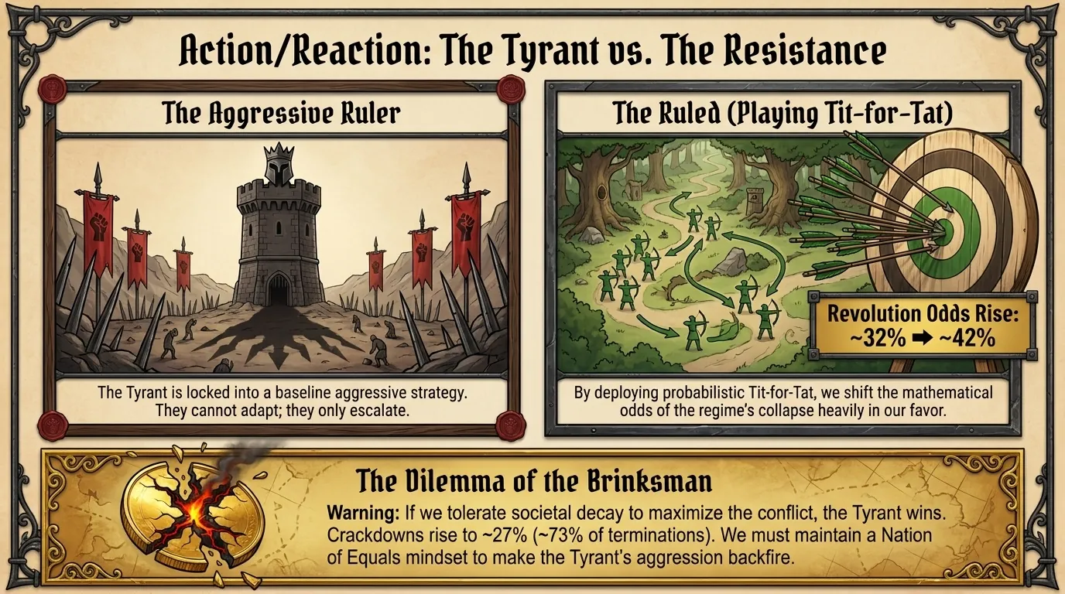
The Aggressive Ruler simulations look at what happens if you start with an oppressive regime and then apply Tit-for-Tat, comparing the results to NN to assess the outcomes.
Both Players have a fixed Baseline Strategy determined at the start of the game, represented by a randomly-selected Probability of Hawkishness above 50% for the Ruler and above 0% for the Ruled. In the Tit-for-Tat variant only the Ruled play Tit-for-Tat while the Ruler keeps its Baseline Aggressive Strategy.
While Tit-for-Tat has a tendency to increase the Total Termination Proportion, it also increases the probability of Revolution relative to Crackdown for most archetypes, meaning that the Aggressive Ruler is more likely to lose if the Ruled apply Tit-for-Tat.
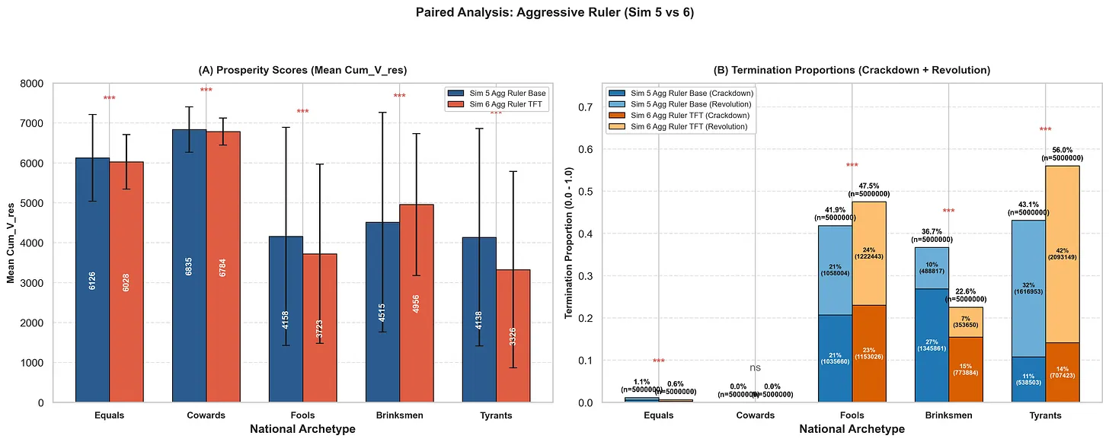
The results here are deeply empowering to anyone living under an oppressive regime.
When faced with an Aggressive Ruler, the Ruled are given two mutually exclusive options: maximise Prosperity, or maximise the probability of the regime collapsing.
In general, an oppressive regime will have an Aggressive Ruler population with a Nation of Tyrants archetype, having a Baseline Indifference to societal decline, and the Nation of Tyrants is therefore the standard for the comparisons that follow.
The probability of Revolution rises from ~32% to ~42% if the Ruled adopt a probabilistic Tit-for-Tat Strategy against a Nation of Aggressive, Tyrannical Rulers.
It is interesting to note that the Nation of Equals is remarkably stable, but Tit-for-Tat no longer restores the Nation of Equals archetype.
Tit-for-Tat heavily favours the Ruled because the Ruler is stuck with an Aggressive Strategy. It is unlikely to find an Aggressive Ruler in a Nation of Equals, the data suggests you will barely notice that they are Aggressive.
The only way the data says you can maximise prosperity under an oppressive regime is if the Ruled takes a Nation of Brinksmen stance: has a Baseline Indifference to the decline of society when establishing a Mixed Strategy.
However, if the Ruled do have a Baseline Indifference to societal decay, Tit-for-Tat significantly improves the odds of the Ruler winning the conflict, from ~11% Crackdowns (~25% of Terminations) to ~27% Crackdowns (~73% of Terminations).

The Aggressive Ruled (Simulations 7 & 8)

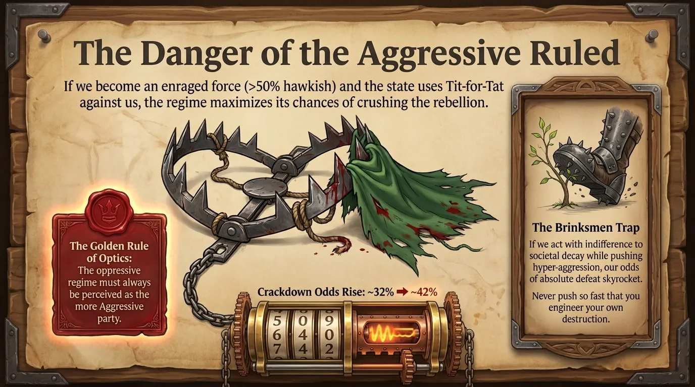
The Aggressive Ruled simulations look at what happens if you start with an enraged population and then the state applies Tit-for-Tat, comparing the results to NN to assess the outcomes.
Both Players have a fixed Baseline Strategy determined at the start of the game, represented by a randomly-selected Probability of Hawkishness above 50% for the Ruled and above 0% for the Ruler. In the Tit-for-Tat variant only the Ruled play Tit-for-Tat while the Ruler keeps its Baseline Aggressive Strategy.
The danger here is that the Ruler can apply Tit-for-Tat against a resistance, and if the resistance is too Aggressive compared to the state, this increases the chances of an oppressive regime winning.
This data serves as a warning for any Strategic Rebel movement not to push too far, too quickly, or too Aggressively, since this might result in your own defeat. The oppressive regime should always be perceived as the more Aggressive party.
The results of the Aggressive Ruler were remarkably symmetrical to the results of the Aggressive Ruled.
When faced with an Aggressive Ruled, the Rulers are also given two mutually exclusive options: maximise Prosperity, or maximise the probability of the regime collapsing.
The average historical revolutionary movement had an Aggressive Ruled population with a Nation of Brinksmen archetype, by having a Baseline Indifference to societal decline, and so this will be our standard for comparison.
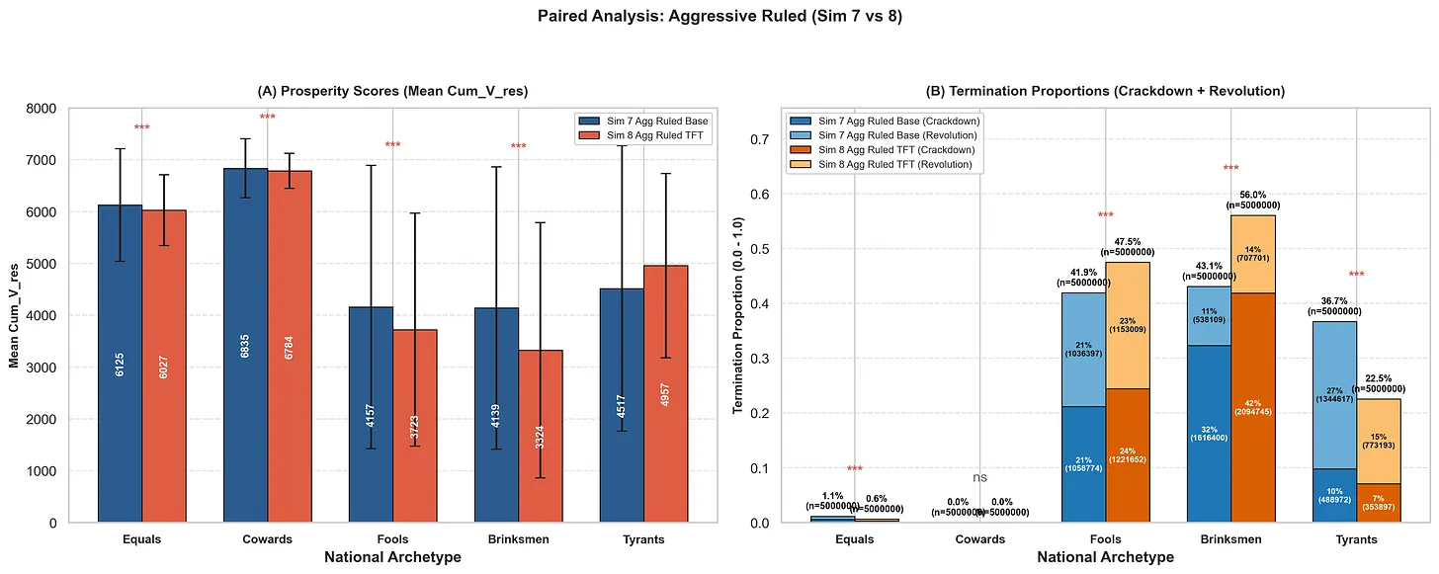
The probability of Crackdown rises from ~32% to ~42% if the Ruler population adopts a probabilistic Tit-for-Tat Strategy.
The Nation of Equals is remarkably stable, but Tit-for-Tat no longer imposes the Nation of Equals archetype – for either Aggressive Temperament. Instead, Tit-for-Tat heavily favours the Ruler because the Ruled is stuck with an Aggressive Strategy. It is unlikely to find an Aggressive Ruled in a Nation of Equals, the data suggests you will barely notice that they are Aggressive.
The only way the data says you can maximise prosperity under an Aggressive Ruled population is if the Ruler takes a Nation of Tyrants stance by having a Baseline Indifference to the decline of society when establishing a Mixed Strategy.
However, if the Rulers do have a Baseline Indifference to societal decay, it significantly increases the odds of the Ruled winning the conflict from ~11% (~25% of Terminations) to ~27% (~73% of Terminations).

Overview of Probabilistic Tit-for-Tat

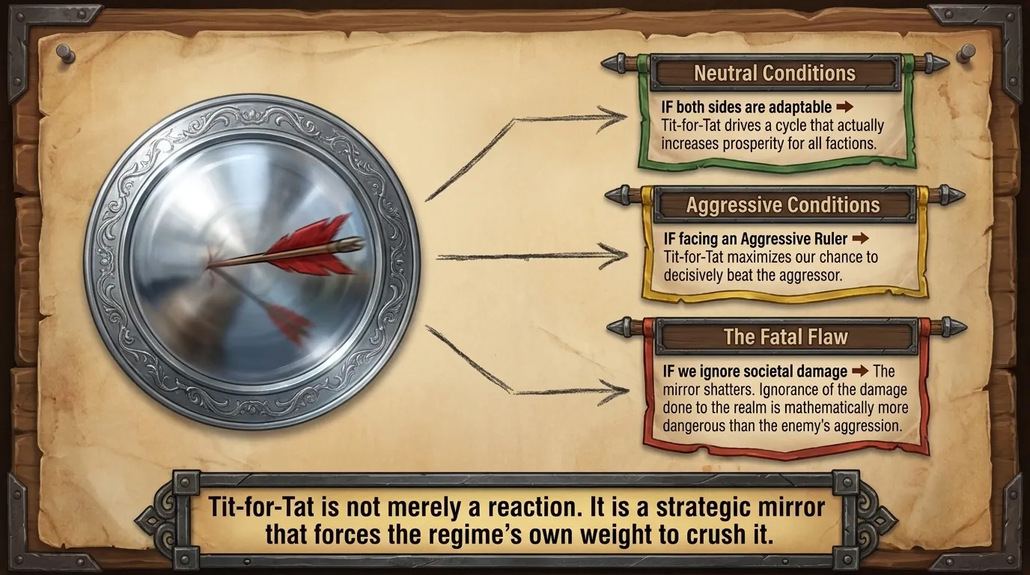
We have demonstrated that Tit-for-Tat is the optimal Strategy under a variety of conditions – only backfiring if your side has a Baseline Indifference to societal decline and the other side is Aggressive.
If both Players are Neutral, Tit-for-Tat leads to a conflict cycle that actually increases Prosperity Scores under all National Archetypes. Tit-for-Tat enforced a Nation of Equals archetype for every National Archetype except the Nation of Cowards, bringing Prosperity Scores up to just under 3% of the Nation of Equals.
Tit-for-Tat also decreases the chance of game ending events, without significantly altering the relative proportions of Revolution and Crackdown.
If one Player is Aggressive, Tit-for-Tat has one of two effects, depending on whether or not the other side is willing to overlook societal decline when establishing Strategies:
- If the other player has a Baseline Indifference to societal decay, they can maximise their nation’s Prosperity Score while also giving the Aggressive Player a major advantage.
- If the other player does not have a Baseline Indifference to societal decay, they can maximise their chance of decisively beating the Aggressive Player.
Tit-for-Tat will not enforce a Nation of Equals archetype when an Aggressive Player is present, but tends to increase the odds that the less Aggressive side will win instead.
Ignorance is always more dangerous to a Player than being Aggressive, and Tit-for-Tat is only ever a tactical disadvantage if the side playing it has a Baseline Indifference to societal decline while the other side is playing Aggressive.
Therefore, under rare conditions, Aggression can be a better tactic than Tit-for-Tat – it depends on how willing your opponent is to ignore the damage that they do.

Imposing a Nation of Equals Archetype

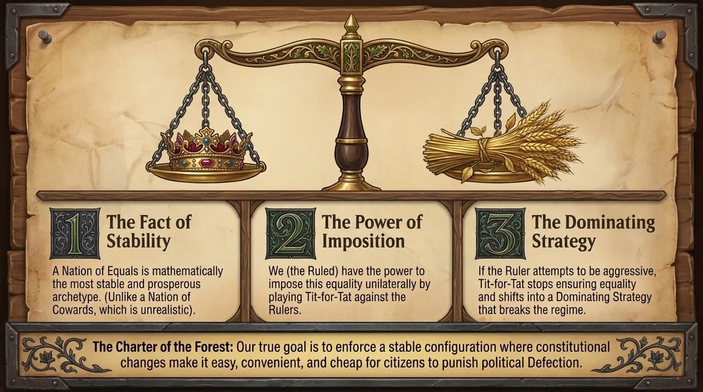
The Ruler vs the Ruled Monte Carlo simulation revealed three vitally important facts for the Strategic Rebel:
- The most stable and prosperous society has a Nation of Equals archetype.
- A Nation of Equals is imposable by the Ruled, by playing Tit-for-Tat against the Rulers.
- Tit-for-Tat shifts from ensuring Equality to becoming a Dominating Strategy if the Ruler tries to be Aggressive.
While the Nation of Cowards technically performed better, the data suggests that Tit-for-Tat imposes a situation that resembles the Nation of Equals, while no means of imposing a Nation of Cowards was suggested by the data.
The Nation of Equals is therefore a stable configuration, which is further demonstrated by its stability in the presence of Aggressive Temperaments.
The Nation of Cowards outperforms the other National Archetypes, but it is not a realistic situation. It implies that neither the Ruler nor the Ruled would try to take advantage of each other as generations progress, but we know that humans do not behave like this.
The Nation of Fools, Nation of Tyrannical Rulers and Nation of Brinksmen Ruled archetypes all had their Prosperity Scores restored to just under 3% of the value of a Nation of Equals archetype when Tit-for-Tat was implemented.
The data is extremely clear that the goal of a successful Strategic Revolution should to be to enforce the Nation of Equals archetype, logic suggests that this would require constitutional amendments based on Mechanism Design.
Currently, citizens are forced to organise, officially or unofficially, to try to impose Costs on politicians that Defect to Subverter interests. However, a successful Strategic Revolution should seek to make constitutional changes to impose easy, convenient, and low personal cost mechanisms for citizens to punish political Defection to Subverter interests.
We will conclude the discussion of the Monte Carlo simulation results with a brief introduction to Dynamism and the use of Game Theory and Mechanism Design to restructure the state so that power flows Dynamically: from the top down and from the bottom up simultaneously. Both sides need to have the ability to impose costs on the other for Defection.
We already have the police to deal with Defection from the Ruled, but that also means that we have already proven that the police cannot be viewed as a structure that is capable of handling Defection from the Rulers...

Dynamism and the Dynamic State
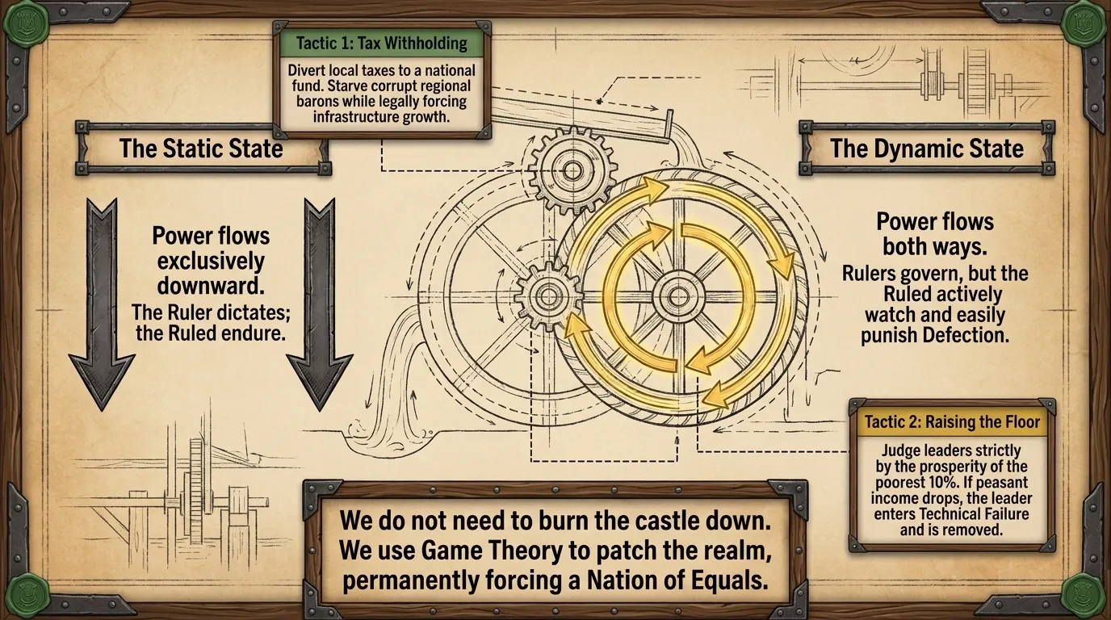
The Ruler vs the Ruled Monte Carlo simulations do not take ideology into account, other than its potential to blind ideological adherents to the damage that they do to society.
Probabilistic Tit-for-Tat is therefore likely to work under any political system, regardless of which political camps are present.
The model suggests that the best set up for a state is one in which power flows both ways: the Rulers ruling the Ruled, and the Ruled acting as the watchmen and punishing the Ruler population for Defection by also Defecting, making it clear to the Ruler that Tit-for-Tat is at play when you do Defect.
Dynamism is the idea that states should be structured using the principles of Game Theory and Mechanism Design to ensure that the Ruler does not Defect, and to minimise the potential damage that Defection can have on society.
A Static State has power flowing down from the Ruler to the Ruled, a Dynamic State has power flowing both ways.
The state is just a system, and systems can be designed or redesigned. The ultimate goal of a Strategic Rebel must to force a situation where Mechanism Design is used to redesign the state, giving Tit-for-Tat mechanism to the population that is enforced by law.
One such mechanism is to allow citizens to withhold tax paid to Local Government by paying it to National Government instead, along with a reason for the protest for analytic. This deprives the Regional Government of its expected budget, while National Government can be forced to use the money on economic stimulus projects like infrastructure.
Another mechanism, currently the most elegant mechanism that I can think of as the basis for a state, is to enshrine the principle of Raising the Floor in the constitution.
If a chain is only as strong as the weakest link, then the state is only as rich as its poorest 10%. Therefore, a politician’s performance needs to be judged on his ability to raise the average income of this population: to Raise the Floor.
If the income of the bottom 10% decreases, the politicians involved are classified as Technical Failures, and their enemies can use that against them.
This doesn’t prevent corruption, but any corrupt arrangement would have to be structured to avoid Technical Failure status, minimising the extent of harm that corruption could do.
A third mechanism is possible in combination with Raising the Floor: tax brackets can be set based on the national average income.
If Raising the Floor is preventing the poor from getting poorer, then a growing wealth gap would move the poorer parts of the population into lower tax brackets, placing the largest portion of the tax burden on the rich.
Conversely, the rich can reduce their tax burden by ensuring that their employees are paid at a level that keeps the wealth gap low enough not to hurt the employers via personal income tax.
Without Raising the Floor, this mechanism can be gamed by making sure that teh poor and rich diverge at a constant rate, keeping the national average roughly the same.
These are only three reasonable mechanisms, provided as proof of concept that it may not be necessary to tear any system down.
Game Theory can be used to introduce patches to existing systems instead. You only need to force mutual Cooperation and disincentivise Defection to Subverter interests.
While an oppressive regime is going to have to be forced to make the concessions, our models suggest that such societies are doomed to collapse. In reality, the Ruled will be more willing to make concessions if it looks like a Revolution is coming and so the natural decline of these states is to the advantage of the Strategic Rebel.
Game Theory for Rebels proposes a society based on the principle of Tit-for-Tat between Ruler and Ruled populations. Tit-for-Tat maximises the Prosperity Score for the Ruled, but it also maximises it for the Ruler. It is also remarkably effective at doing so.
Therefore, convincing a collapsing society to restructure from a Static to a Dynamic system is not likely to be difficult, because no other option being proposed maximises value for both populations.
The data makes it very easy to argue that a better approach to society is to use Mechanism Design to enforce a Nation of Equals archetype, and that the top-down approach that has defined human history is actually a primitive way to structure society.

